PPG meeting minutes: 22 February 2017
All Staff and 6 patients present.
Barnali to open: Thank you everyone for coming.

Welcome: Everyone at Spur Road Surgery would like to thank the patients. Without their support there will be no meeting. If there is no meeting then the practice cannot give any feedback or updates.

Care Quality Commission (CQC): They inspect all GP practices, dental practices and care homes to check for standardisation. They judge the practices on safety, effectiveness, caring, well led & responsive.

CQC came to Spur Road Surgery on the 12th of January 2017. The partners were very worried as CQC have the power to close down surgeries. They have done this to a few practices in Haringey. The CQC came in thinking we were a single handed practice but due to Dr Northrop singing on as a partner this is no longer the case. They found us really good and they commended the practice on various things. The surgery had done it with the patients help. We called on a few patients who came and represented our PPG. The CQC looked into all the past PPG meeting minutes and saw that we were well led. Both the doctors are doing well. They also mentioned that we are a nugget of good practice.

What was the result on the day? Though we are good in specific areas, overall we need improving. This was due to the fact that under the subheading caring the 2015-2016 National Patient survey put us just below the national average. Out of 325 surveys that went out only 95 were returned.

Since the CQC left a draft report, two practice managers have written back to them giving more evidence towards the result. Evidence such as the Friends and Family test (results are below) which show us at the top have been given.

When the final report is received, it will be published on the website and we will inform the patients.

Website: We have a brand new website! www.spurroadsurgery-tottenham.co.uk. Today and previous PPG meeting minutes can be found there plus the latest updates and any queries e.g. Blood test opening times at Laurels. Below is a screenshot of the front page. If there is anything you think should go into the website please let Promita know.
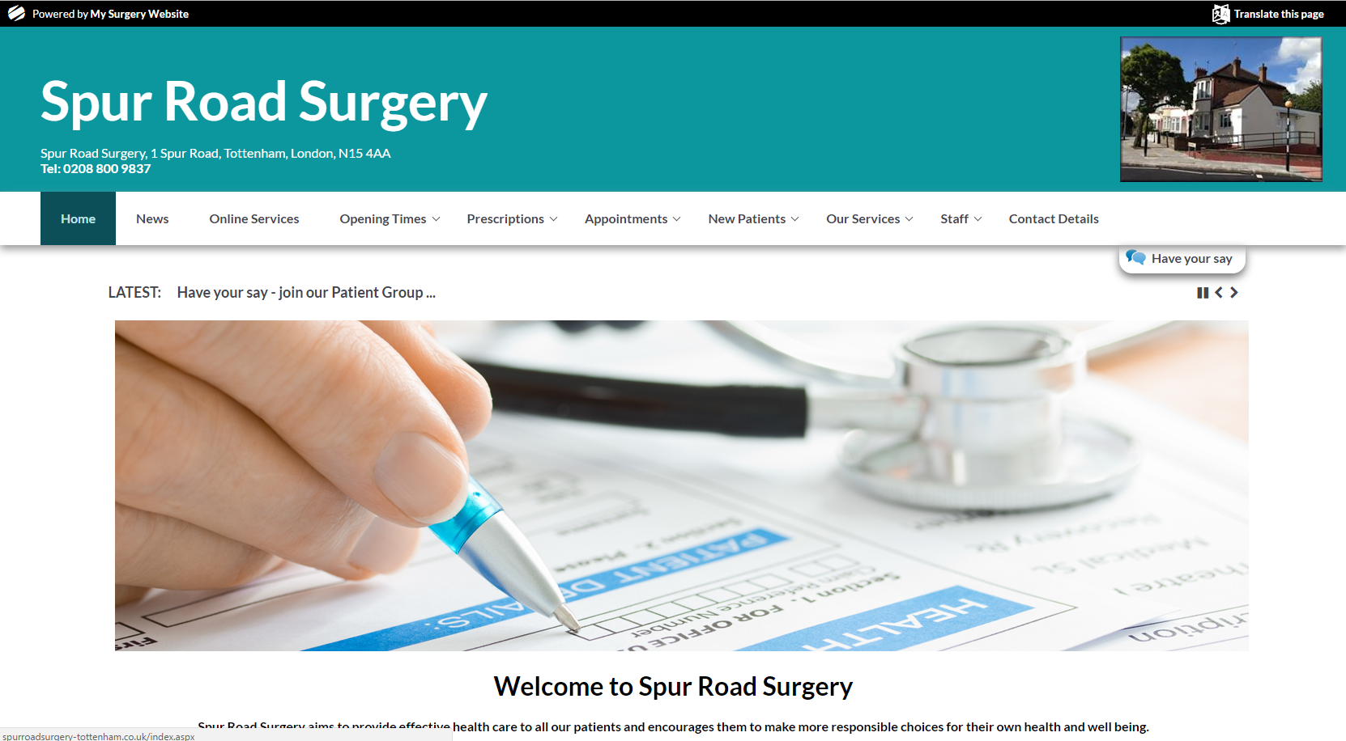
Improvements: Business Continuity Plan (BCP): A Business continuity planning is the process of creating systems of prevention and recovery to deal with potential threats to a company. E.g. If there is a fire and the building burns down what do we do?

The BCP was discussed and accepted in the meeting. An edited version can be found on our website.

Finance: Income is generated into the practice by the services that we provide. There are various responsibilities that the practice takes e.g. cervical smear, regular immunisations, blood pressure monitoring.

Improving the practice: To increase the services we offer the practice is always bidding for new equipment when the CCG allocates any funding. We are doing well in all the services we offer in order to meet targets.

Review: Please leave a review on our website or on the NHS choices website.

Updates: Welcome again to Dr Northrop who has signed on as a doctor of this practice. For the month of March she will do four sessions a week. Below is the doctors’ rota.

 | Morning | Evening
Monday | Dr Dasgupta | Dr Dasgupta
Tuesday | Dr Northop | Dr Northop
Wednesday | Dr Dasgupta
Thursday | Dr Northop
Friday | Dr Northop | Dr Dasgupta

The meeting closed at 3:30pm

